**Name :** **Chhaya Deep Manojbhai**

**Understanding of Hardware and Its**

**Components**

**1. Which of the following is NOT a component of the CPU?**

**1. ALU**

**2. RAM**

**3. CU**

**4. 1 and 3 bot**

**Ans** . RAM Because the CPU is separate hardware component and Storage data and know is internal storage.

**2. What is the function of RAM in a computer?**

**Ans**. RAM keeps data easily accessible so your processor can quickly find it without having to go into long-term storage.

**3. Which of the following is a primary storage device?**

**1. HDD**

**2. SSD**

**3. SD card**

**4. 1 and 2 both**

**Ans**. HDD because the HDD is store backup data.

**4. What is the purpose of a GPU?**

**Ans.** GPU (Graphics Processing Unit) the main purose in your device helps handle graphics-related work like graphics, effects, and videos.

**Section 2: True or False**

**5. The motherboard is the main circuit board of a computer where other components are attached.**

**Ans**. True because the All component and external peripherals connects.

**6. A UPS (Uninterruptible Power Supply) is a hardware device that provides emergency power to a load when the input power source fails**

**Ans** . True because when the power cut it protecting equipment form damage if the power source fails

**7. An expansion card is a circuit board that enhances the functionality of a component**

**Ans.** True

**Section 3: Short Answer**

**8. Explain the difference between HDD ad SSD**

**Ans .**

|  |  |
| --- | --- |
| **HDD**   1. **Hard Disk Drive** 2. **HDD is cheper than SSD** 3. **HDD having moving parts** 4. **HDD is slower than SSD** | **SSD**   1. **Solid State Drive** 2. **SSD is more expensive than**   **HDD**   1. **SSD not have any non-moving part** 2. **SSD is Faster than HDD** |

**9. Describe the function of BIOS in a computer system.**

Ans . **Function :** The BIOS chip starts up the computer, loads basic drivers, loads the operating system, checks hardware systems, and loads other BIOS programs on the computer.

10. List and briefly explain three input devices commonly used with computers.

**Ans . 1.Keyboard 2. Mouse 3. Scanner**

1. **Keyboard** : Keyboard input device used to enter characters and functions into the computer system by pressing buttons, or key. It is the primary device used to enter text
2. **Mouse :** Mouse is used to select items on the screescan and to give instructions to your computer to perform tasks.
3. **Scanner :** Scanner is an electronic device that captures documents, photographs, and other printed material and saves them as digital files.

**11. Identify and label the following components on a diagram of a motherboard:**

**• CPU**

**• RAM slots**

**• SATA connectors**

**• PCI-E slot**

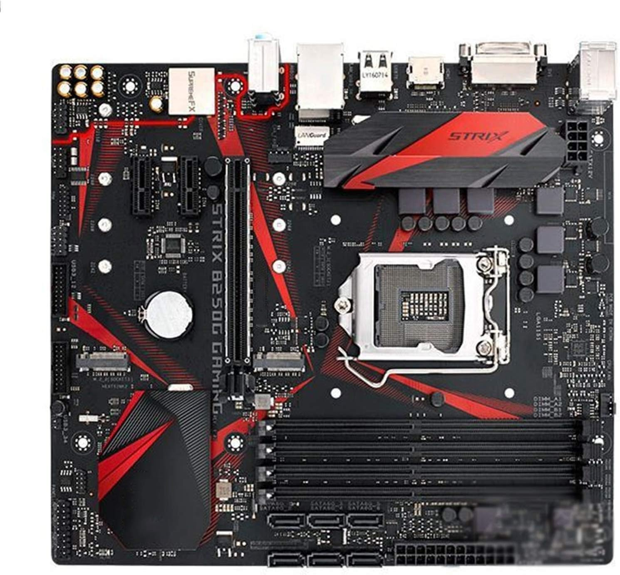

**PCI-ESLOT**

**SATA Connector**

**RAM Slot**

**CPU**

12**. Demonstrate how to install a RAM module into a computer**

**Ans.** The notch on the RAM stick with the ridge in the slot, and firmly press the RAM into the slot until the side clips snap into place, securing the RAM.

**13. Discuss the importance of proper cooling mechanisms in a computer system. Include examples of cooling methods and their effectiveness.**

**Ans**. Proper cooling mechanisms in a computer system are crucial for maintaining optimal performance, ensuring hardware longevity, and preventing system failures. Overheating can cause various issues, including reduced performance, system crashes, and permanent damage to components.

1. **Air Cooling :**

* **Case Fans:** These are the most common cooling solution, using fans to move air through the case, expelling hot air and drawing in cooler air.
* **Effectiveness:** Effective for general use and gaming PCs, where moderate cooling is sufficient.
* **CPU Air Coolers:** These consist of a heatsink and one or more fans mounted directly on the CPU.
* **Effectiveness:** Highly effective for most consumer-grade CPUs, offering a balance between cost, noise, and cooling performance.

1. **liquid Cooling :**

* **Closed-Loop (All-in-One) Liquid Coolers:** These pre-assembled systems circulate a coolant through a loop, transferring heat from the CPU to a radiator.
* **Effectiveness:** Superior cooling performance compared to air coolers, suitable for high-performance and overclocked systems.
* **Custom Loop Liquid Cooling:** These systems allow for customized loops that can cool multiple components, such as the CPU, GPU, and even RAM.
* **Effectiveness:** Offers the best cooling performance and is ideal for high-end and enthusiast builds. However, it is more complex and expensive to set up.

**14. Explain the concept of bus width and its significance in computer architecture**

Ans. Bus width refers to the number of bits that can be transferred simultaneously across a computer's bus. A bus is a communication system that transfers data between components inside a computer or between computers. The bus width is a crucial parameter in computer architecture because it directly impacts the system's data transfer rate and overall performance.

**• Data Transfer Rate:**

* The bus width determines how much data can be transferred in parallel at any given time. A wider bus can transfer more data per clock cycle.
* For example, a 32-bit bus can transfer 32 bits of data at once, while a 64-bit bus can transfer 64 bits simultaneously. This means a 64-bit bus can theoretically transfer data twice as fast as a 32-bit bus, assuming the same clock speed.

• **System Performance:**

* The performance of the CPU, memory, and other components is heavily influenced by the bus width. Wider buses reduce the number of cycles needed to transfer data, thereby improving the efficiency and speed of data processing.
* For instance, if a CPU needs to fetch a 64-bit data word from memory and it has a 32-bit bus, it will need two cycles to complete the transfer. With a 64-bit bus, it can do this in one cycle.

**Addressable Memory:**

* The width of the address bus (a specific type of bus) determines the maximum addressable memory space. For example, a 32-bit address bus can address 2^32 (4,294,967,296) memory locations, or 4 GB of memory.
* Expanding to a 64-bit address bus allows addressing up to 2^64 memory locations, which significantly increases the addressable memory space to 16 exabytes (EB).

**Bandwidth:**

* Bandwidth is the amount of data that can be transferred per unit of time. It is calculated as the product of bus width and bus speed (clock frequency).
* A wider bus increases the potential bandwidth, allowing more data to be transferred within the same time frame. This is particularly important for applications requiring high data throughput, such as video editing, gaming, and scientific computations.

**Compatibility and Scalability:**

* The bus width affects the design and compatibility of peripheral devices. Components like GPUs, memory modules, and storage devices must match the bus width of the system for optimal performance.
* Scalability is also influenced by bus width. As newer technologies demand higher data transfer rates, increasing the bus width becomes a crucial step in meeting these requirements